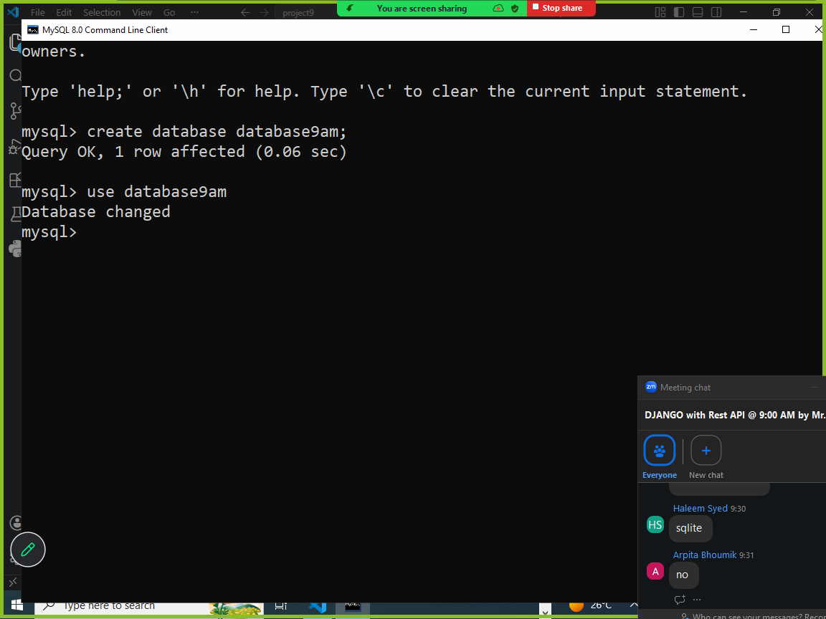

Settings.py (configure backend)

DATABASES = {
'default': {
'ENGINE': 'django.db.backends.mysql',
'NAME': 'database9am',
'USER':'root',
'PASSWORD':'root',
'HOST':'localhost',
'PORT':3302,
}
}

Models.py

from django.db import models

# Create your models here.

class Student(models.Model):
rollno=models.IntegerField(primary_key=True)
name=models.CharField(max_length=20)
course=models.CharField(max_length=15)
fees=models.FloatField()

settings.py

INSTALLED_APPS = [
'django.contrib.admin',
'django.contrib.auth',
'django.contrib.contenttypes',
'django.contrib.sessions',
'django.contrib.messages',
'django.contrib.staticfiles',
'app1',
]

Migrations

- makemigrations
- migrate

python manage.py makemigrations
python mangae.py migrate

makemigrations
makemigrations command create migration file(.py)
this migration file is created by reading models information exist in models.py
makemigration create database schema (structure)
makemigration does not do anything on database
This is a first command which have to run after creating models.
This database schema module or file is created inside application folder.
Database schema is useful to maintain different versions (model changes) of database

PS D:\Backup\Django9amMar\project9> python manage.py makemigrations
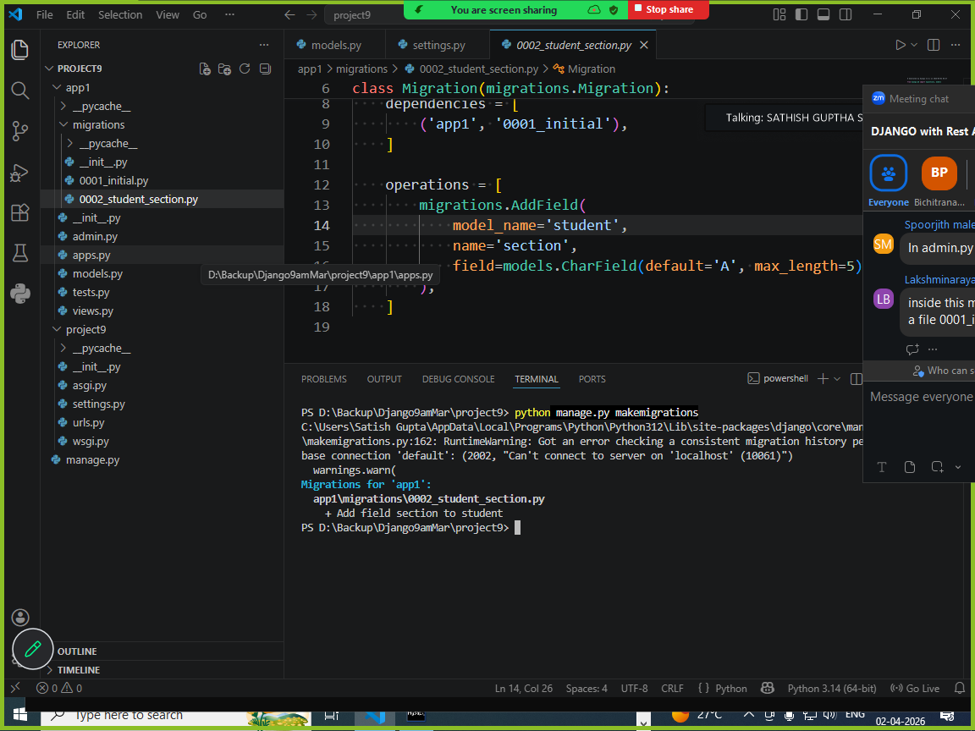

migrate

This command apply changes to database
Migrate command uses migration file and execute these changes on database.
This command connect to database and create tables (for each model it generates one table).

PS D:\Backup\Django9amMar\project9> python manage.py migrate

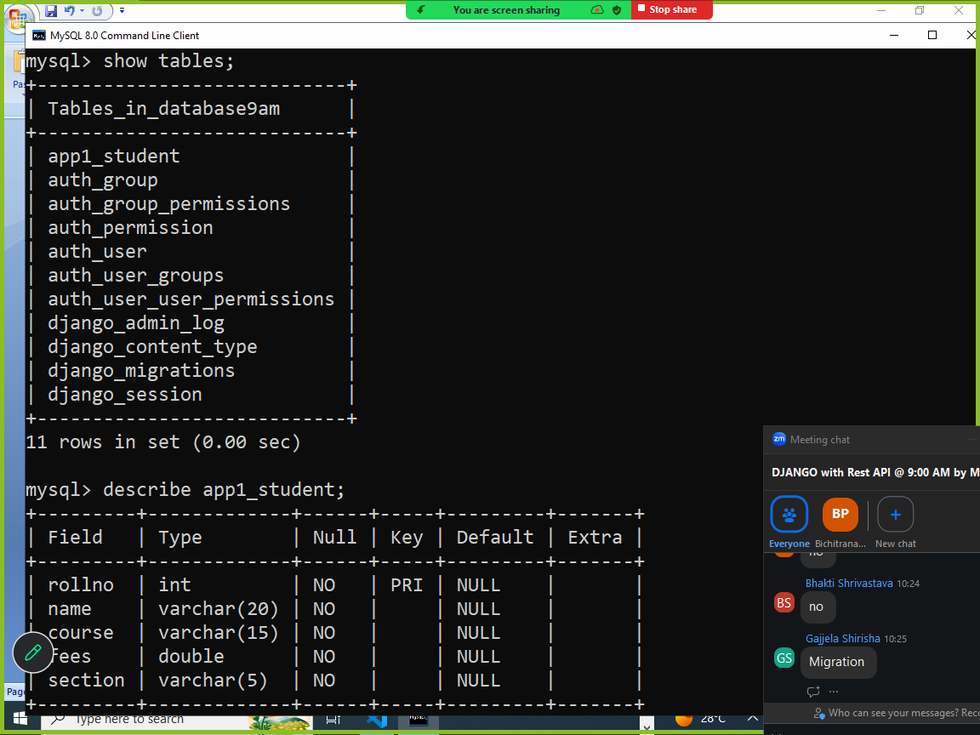

Add one more model inside models.py

class Teacher(models.Model):
teacherid=models.IntegerField(primary_key=True)
teacher_name=models.CharField(max_length=20)

PS D:\Backup\Django9amMar\project9> python manage.py makemigrations
Migrations for 'app1':
app1\migrations\0003_teacher.py
+ Create model Teacher
PS D:\Backup\Django9amMar\project9> python manage.py migrate
Operations to perform:
Apply all migrations: admin, app1, auth, contenttypes, sessions
Running migrations:
Applying app1.0003_teacher... OK
PS D:\Backup\Django9amMar\project9>

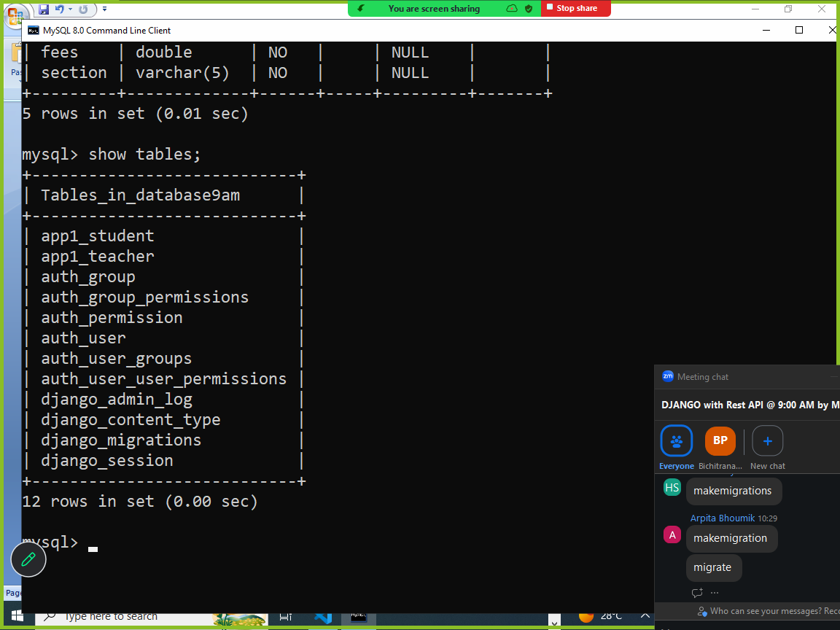

What is difference between makemigrations and migrate?

Feature | makemigrations | migrate
Primary Purpose | To record changes made to models. | To apply recorded changes to the database.
Output | A .py migration file. | Updated database tables/schema.
Database Impact | None. | Modifies the database.
Workflow Order | Step 1: Prepare the changes. | Step 2: Execute the changes.

How change database table name?
Inside model class define a inner class called Meta
Meta class represents metadata of model

models.py
class Employee(models.Model):
empno=models.IntegerField(primary_key=True)
ename=models.CharField(max_length=20)
class Meta:
db_table="emp"

db_table is an attribute of meta class, which define database table name.
by default database table is crated with applicationname_modelname

example: app1_student, app2_employee

Performing crud operation on model?

